# Web Programming

Class Exercise for Bootstrap /Carousel Concept

(it’s not graded but very important for your major project)

## Instructions for Setting Up the Week 3 Exercises

## 1. Create a New Folder:

## - In your local wp directory (that is in the htdocs directory of XAMPP), create a folder named week14.

## 2. File Placement:

## - Place all new files for the exercises inside the week3 directory.

## 3. Naming Conventions:

## - Ensure there are no spaces in any file or folder names.

## - Use only lowercase letters for naming folders and files.

## 4. Reasons:

## - Avoiding spaces and using lowercase helps ensure compatibility with web environments, including case-sensitive servers like those at RMIT.

## Exercises

Create a website about the ‘big cats’. The ‘big cats’ is an informal term generally taken to mean the four largest cats, which are the only ones that can roar. These are the tiger, lion, jaguar and leopard. The site should have a home page (index.html) and a page for each of the cats (lion.html, etc).

The site should have a responsive layout, i.e., the number of columns should change depending on the size of the screen. The greatest number of columns is 3. The entire content of a page should occupy the same width.

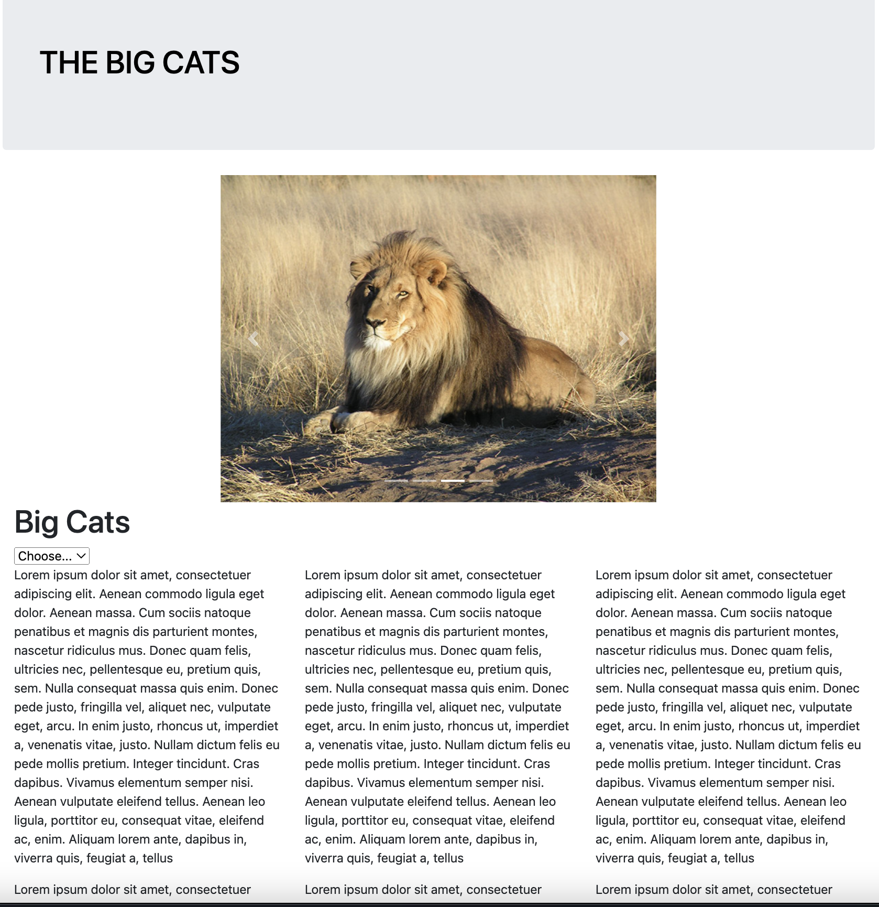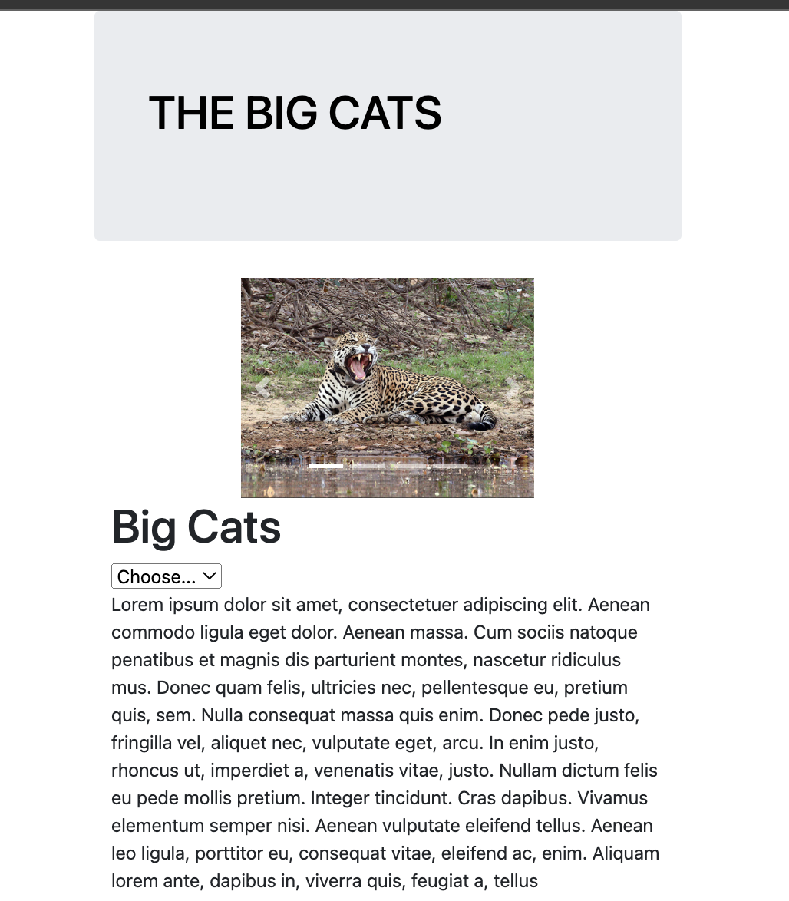

Your site should be built using the Bootstrap framework, with some additional CSS and JavaScript provided by you. Implement the drop-down menu as has been shown in class using simple JavaScript as demonstrated in notes and exercises (not Bootstrap).

Use a Content Delivery Network (CDN) for necessary Bootstrap files.

The home page has a Bootstrap image carousel. You may need to research this on w3schools or check the Olympics example with a carousel. The images for the carousel are provided in a directory called **images_for_carousel**. Note that the images are centred and resized when the window is small. You may need to research this behaviour.

Each individual cat page has an element with jumbotron class at the top. This also has a class that you must define in your own css file to place the background image. These are not the same as the carousel images. The number of columns changes in the same way that the home page does. The relevant text is not required, but some text is required (eg lorem ipsum), with at least three paragraphs.

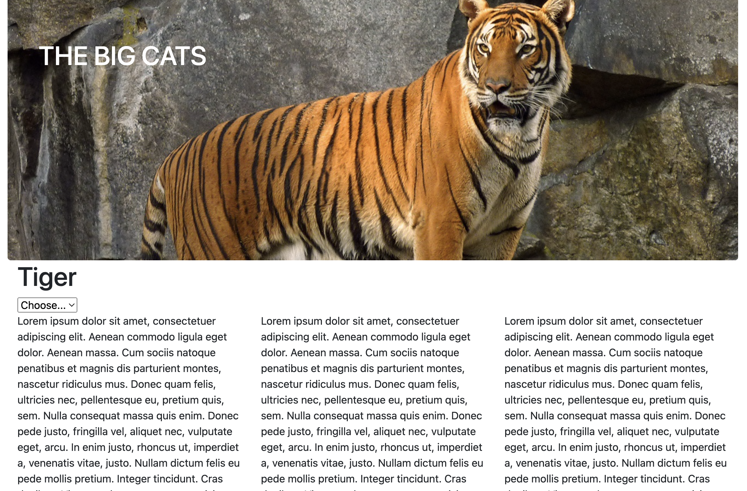

Add an appropriate HTML5 element before the closing body tag for a copyright notice (your name).

Ensure that your pages are valid using **validator.w3.org** and display correctly in at least two browsers.

## Committing Exercise Files to Git via Visual Studio Code

1. **Open Your Project in VS Code**:

- Launch VS Code.

- Open your project folder (**week14**) by going to File > Open Folder and selecting your project directory.

2. **Stage Your Changes**:

- In VS Code, go to the Source Control panel (the icon looks like a forked branch on the sidebar).

- You'll see a list of untracked/changed files. Hover over the "Changes" section and click the '+' icon to stage all changes, or stage individual files by clicking the '+' icon next to each file.

3. **Commit the Changes**:

- After staging, type a commit message in the input box at the top of the Source Control panel. Follow best practices for commit messages (clear, concise, and descriptive).

- Click the Commit button and select “Commit & Sync” (you can also use “Commit & Push”)

## Deploy Code to the RMIT webserver

1. Open Terminal or Command Prompt:

- On your local machine, open your terminal or command prompt.

2. SSH into the Server:

- Use the command **ssh s1234567@titan.csit.rmit.edu.au** where s1234567 is your student ID

- Enter your RMIT password.

3. Navigate to the **wp** Directory:

- Once connected, navigate to the directory where your Git repository is located on the server using **cd ~/public_html /wp**.

4. Pull the Latest Changes:

- Run the command **git pull origin main** to pull the latest changes from the remote repository.

5. Exit SSH Session (optional):

- After pulling the changes, you can end your SSH session by typing **exit**